***Day 3 – API Integration Report – Foodtuck***

Step 1 = API / ENDPOINTS

* Data Structure: API provides product data and chef data for ex:

‘productName’ , ‘image’ , ‘id’ , ‘price’ , ‘inventory’ , ‘colors’ etc.

* Library used = Axios was used to fetch data from sanity
* API Endpoints =

1. <https://sanity-nextjs-rouge.vercel.app/api/foods>
2. <https://sanity-nextjs-rouge.vercel.app/api/chefs>

Step 2 = Fetch data from Sanity

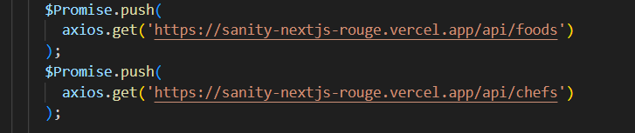

Step 3 = Migration to sanity

Both chefs and product data sent to sanity :

Product data sent to sanity:

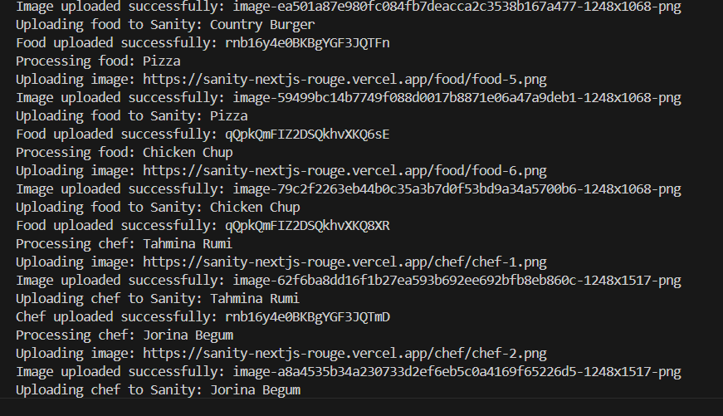Chef data sent to sanity: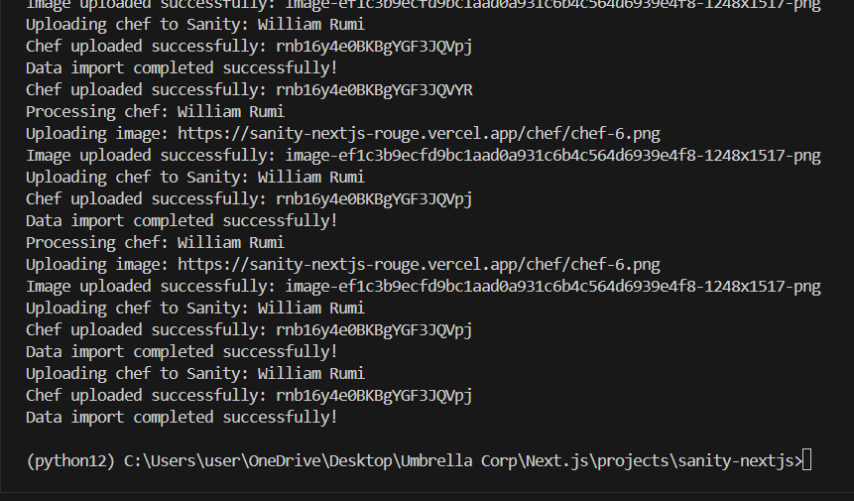

Step 4 = Checking Imported Data in Sanity Using GROQ Query:

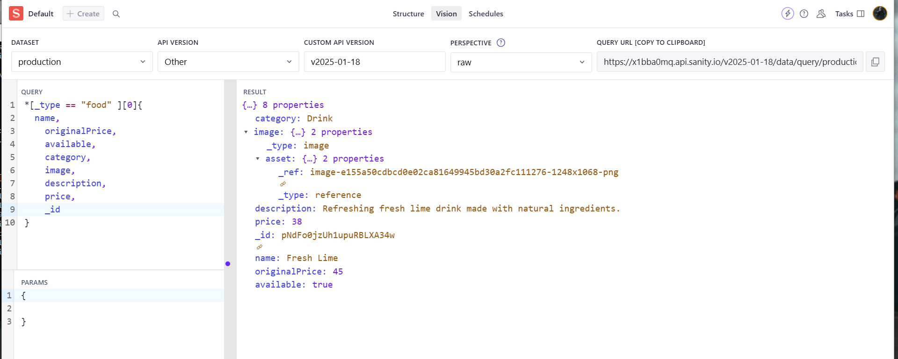

Query used =

1. For Food

*[_type == “food”]{

Name, OriginalPrice, Category, Image, Description, Price,

_Id }

1. For Chef

*[_type == ‘chef’]{

Name, position , _id, description , image

Step 5 = Data Populated in Sanity :

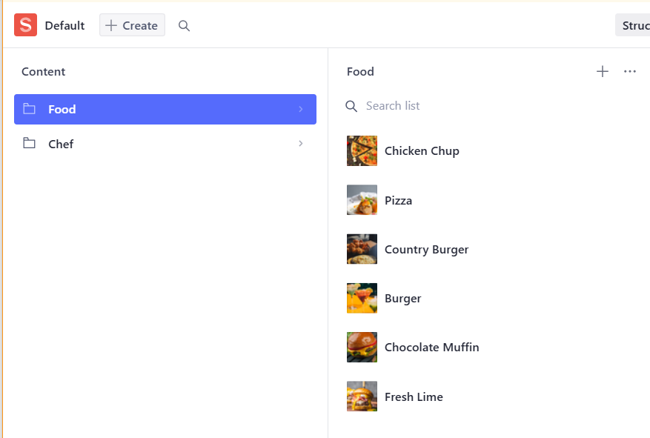

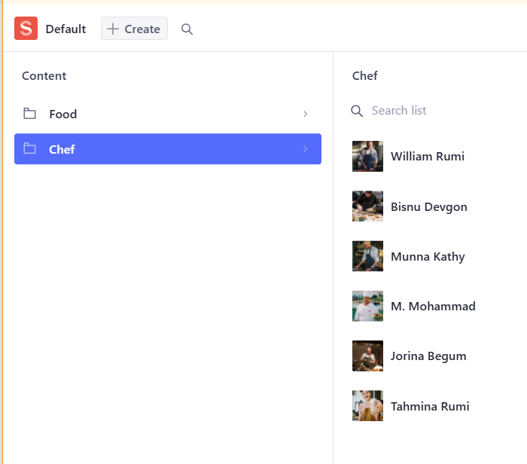

Step 6 = Fetching data on frontend from Sanity :

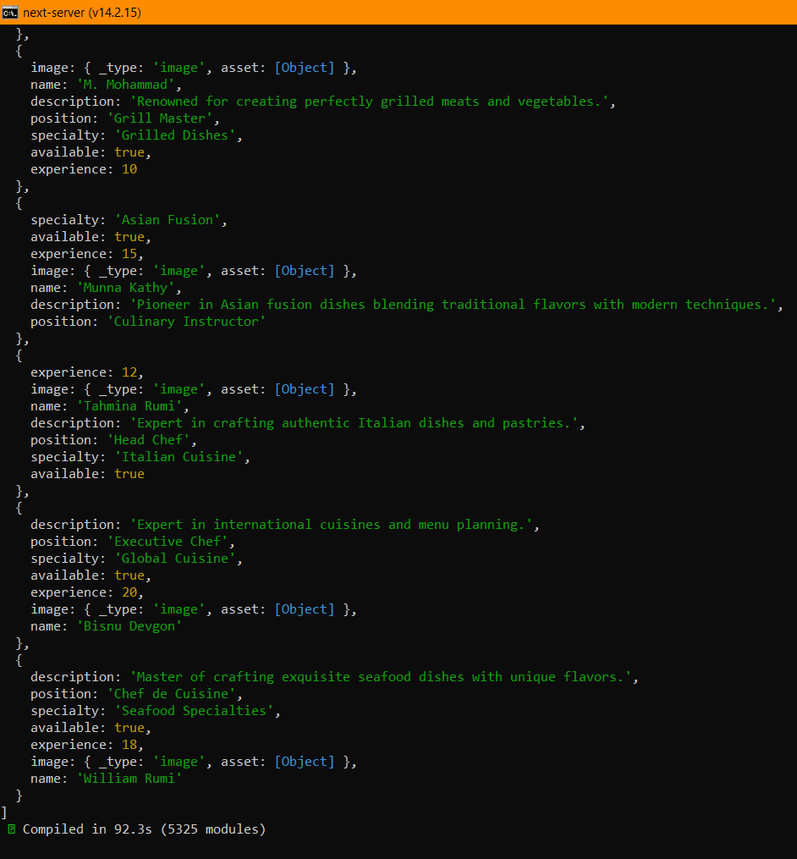

Step 7 = Displaying on Front-end

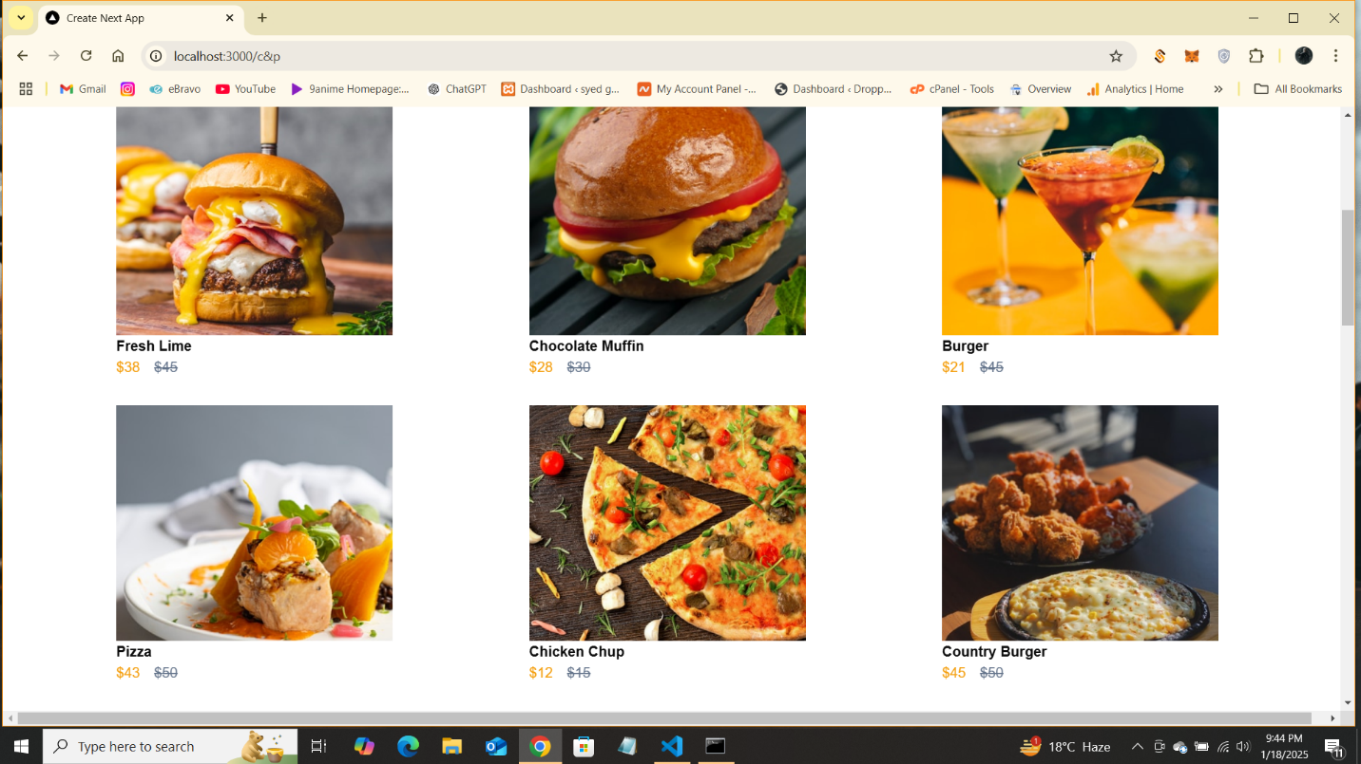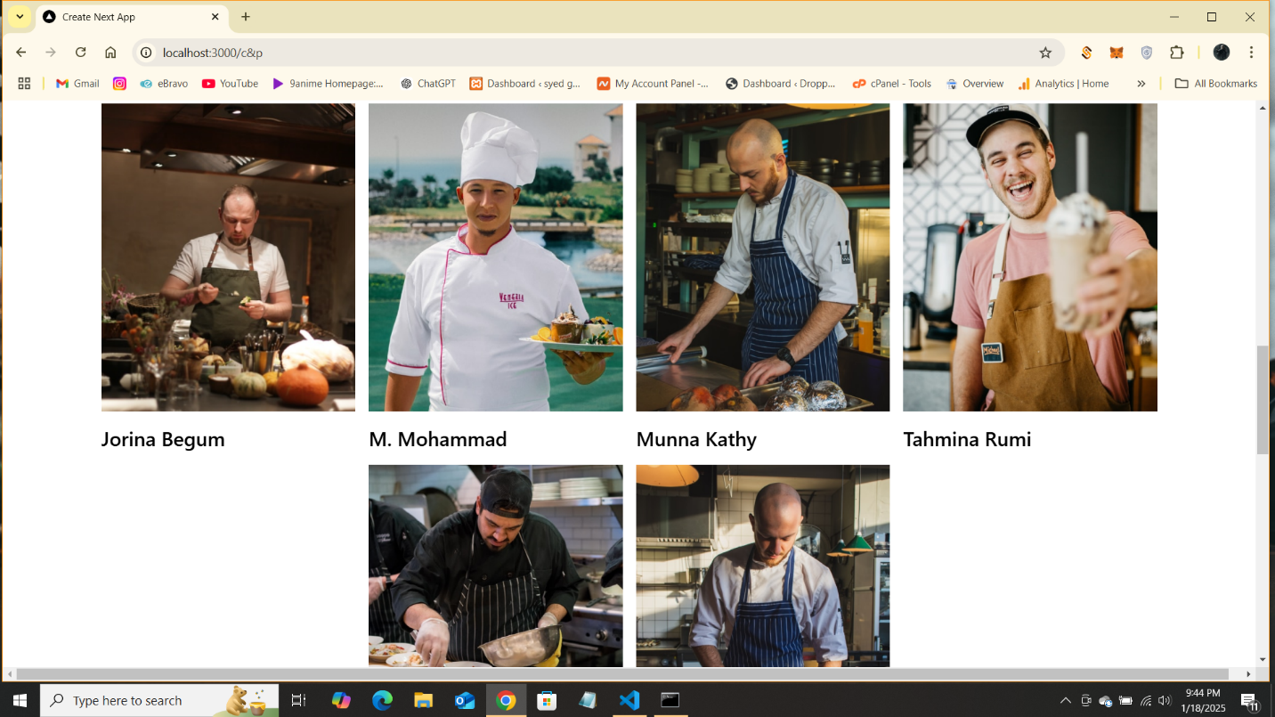

Self-Validation Checklist:

1. API Understanding: ✔
2. Schema Validation: ✔
3. Data Migration: ✔
4. API Integration in Next.js: ✔
5. Submission Preparation: ✔